**Mastering the Misunderstood Art of**

**self-discipline**

* Training and control of oneself and one's conduct, usually for personal improvement.

As Dale Carnegie said

“The most tragic thing I know about human beings is that we all tend to put off living.”

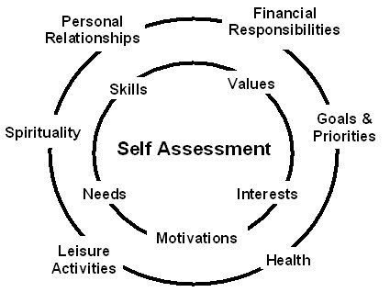

Question: "What does the Bible say about self-discipline?"

Answer: Self-discipline is essentially the same as self-control, one of the nine fruits of the Spirit listed by Paul in Galatians 5:22-23. The KJV translation uses the word temperance in place of “self-control” which, like self-discipline, generally refers to our ability to control or restrain ourselves from all kinds of feelings, impulses, and desires, which includes the desire for physical and material comfort. Now, even though self-control is the last of the spiritual fruits mentioned by Paul, and even though it is a term not used extensively in the Bible, self-control is clearly an indispensable attribute of the Christian life, especially as our unredeemed flesh sometimes causes us to succumb to the persistent tug of our sinful desires.

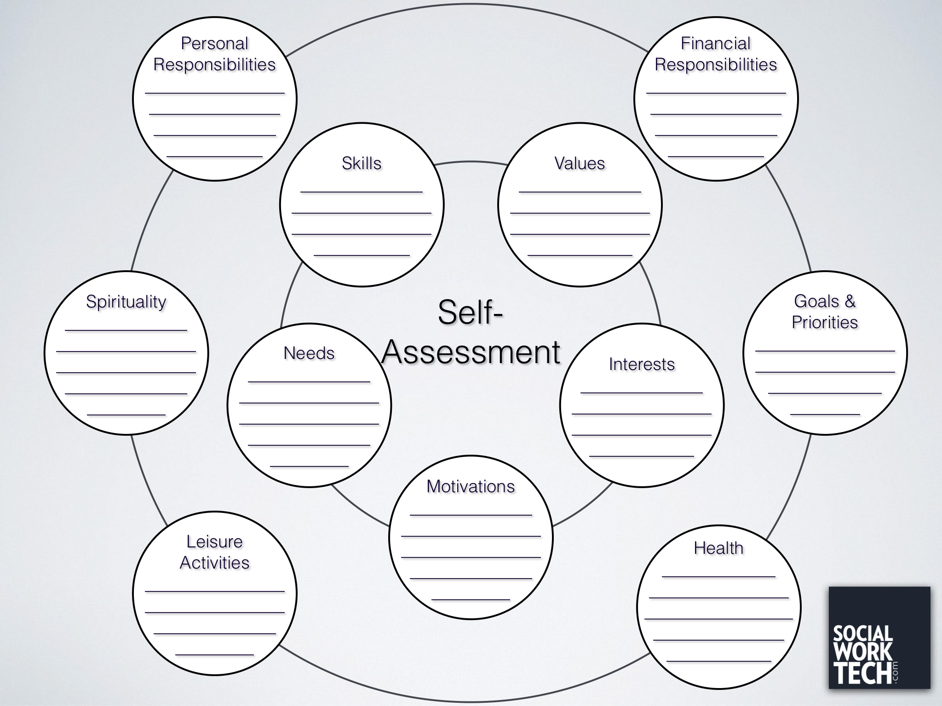

Today Date:

Journey Notes